Crossed Triangular Cuploid

Definition
# Source: AI Source: Provided by: [Data Path: Persons Table -> ID Column: 1, Name_En Column: Motasem Essam] -> From: [ChatGPT] on [7/25/2026]
A Crossed Triangular Cuploid, also known as a {3/2}-Cuploid, is a specialized non-orientable polyhedral construction related to the cupola family.
It is formed using a crossed triangular arrangement in which the lower polygonal base becomes degenerate and is removed. The triangular and square faces connect directly along the edges where the missing base would have been.
The Crossed Triangular Cuploid is closely associated with the Tetrahemihexahedron, a non-orientable polyhedron.
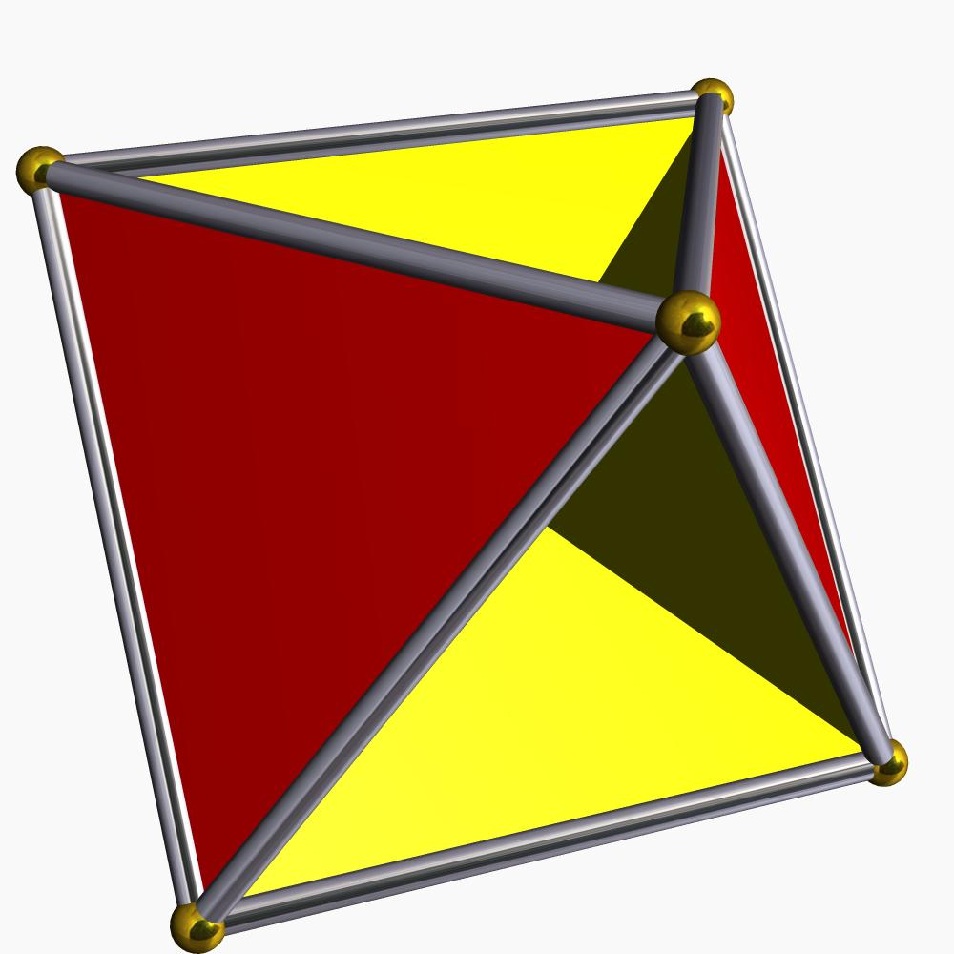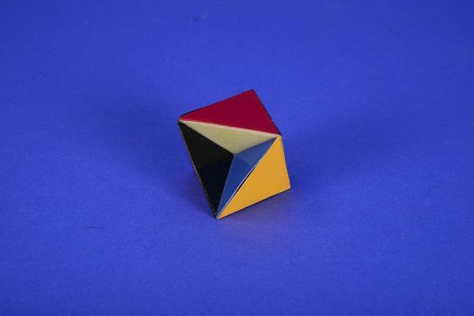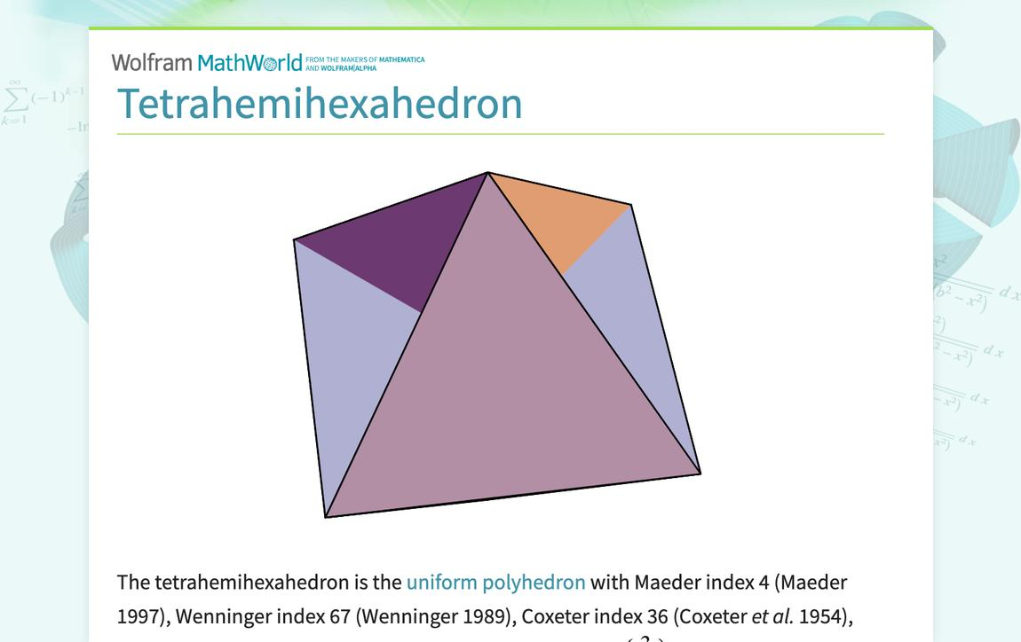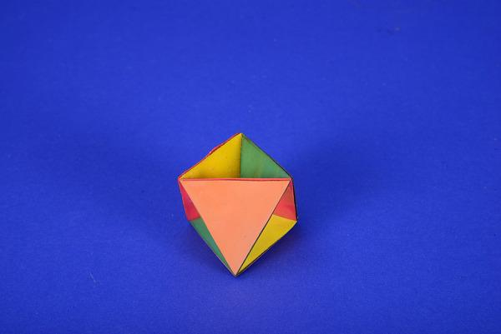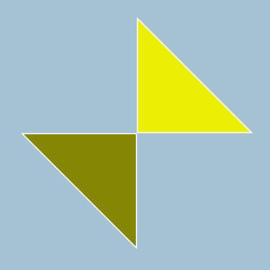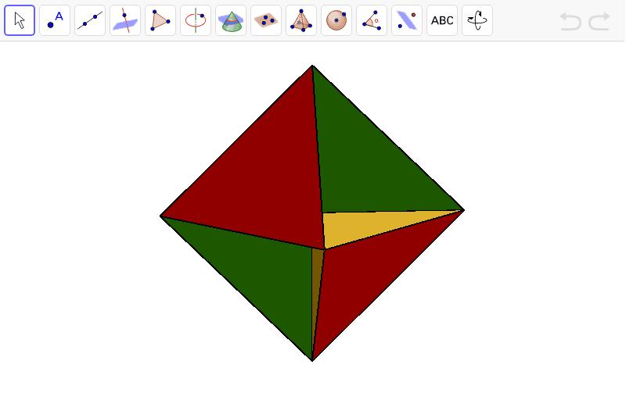

Simple Definition
# Source: AI Source: Provided by: [Data Path: Persons Table -> ID Column: 1, Name_En Column: Motasem Essam] -> From: [ChatGPT] on [7/25/2026]
A Crossed Triangular Cuploid is a special three-dimensional geometric structure made from triangular and square faces arranged in a crossed configuration, with no ordinary lower polygonal base.

Geometric Structure
# Source: AI Source: Provided by: [Data Path: Persons Table -> ID Column: 1, Name_En Column: Motasem Essam] -> From: [ChatGPT] on [7/25/2026]
Its structure is based on the star-polygon notation:
$$\{3/2\}$$
- 3 represents three vertices.
- 2 represents the step size used when connecting the vertices.
- The connections produce a crossed triangular arrangement.
- The corresponding lower base would be degenerate, so it is removed.
- Triangular and square faces connect directly instead of attaching to a normal lower base.
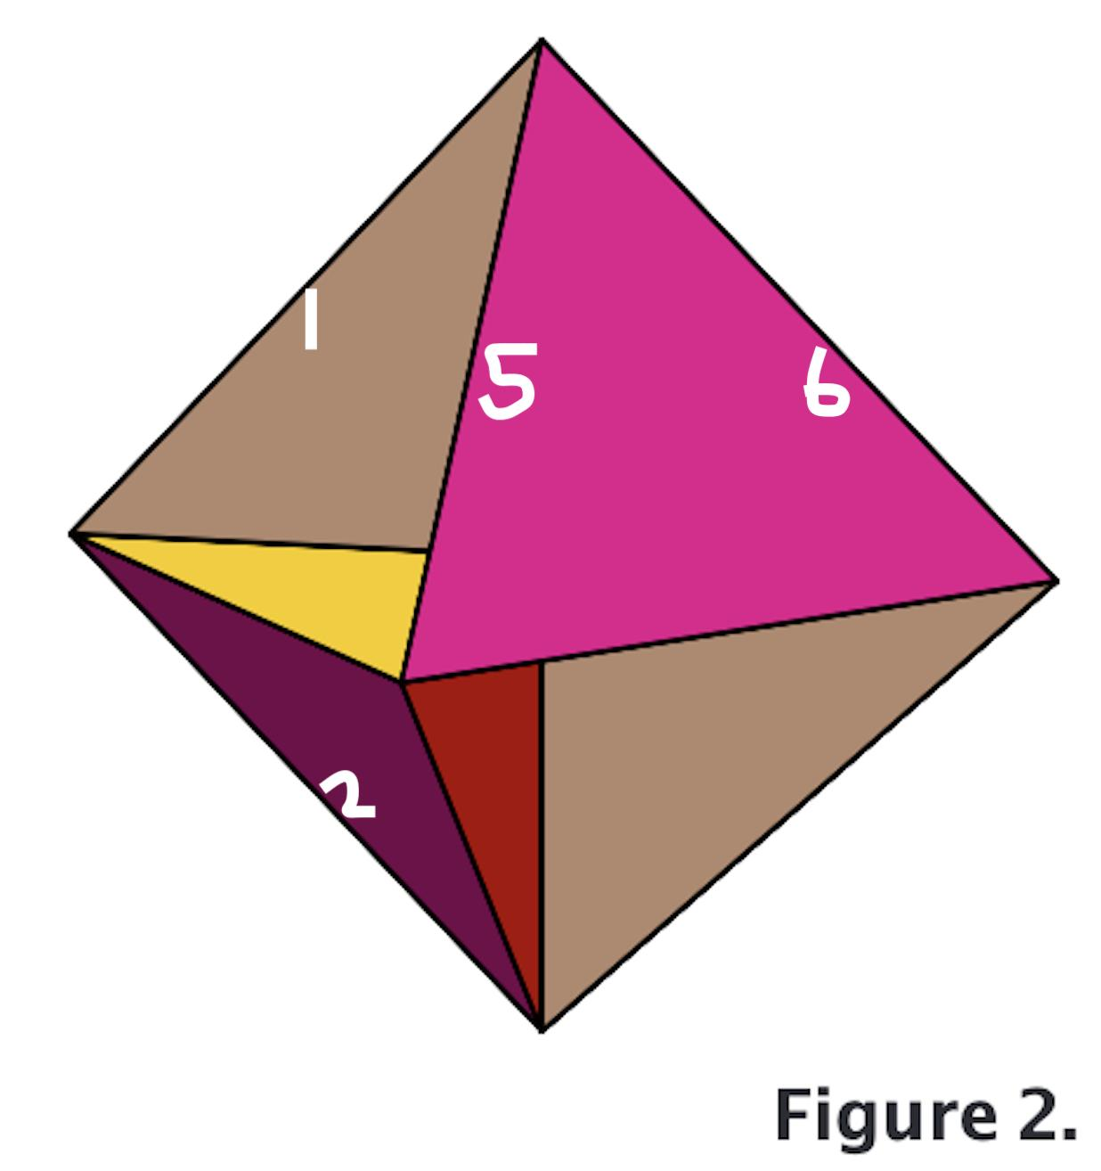

Face Structure
# Source: AI Source: Provided by: [Data Path: Persons Table -> ID Column: 1, Name_En Column: Motasem Essam] -> From: [ChatGPT] on [7/25/2026]
The associated tetrahemihexahedron has:
- Triangular faces.
- Square faces.
- A crossed, non-orientable arrangement of its faces.
For the tetrahemihexahedron realization, the face counts are:
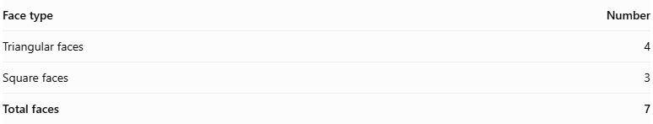
Face type | Number
Triangular faces | 4
Square faces | 3
Total faces | 7

Edge Structure
# Source: AI Source: Provided by: [Data Path: Persons Table -> ID Column: 1, Name_En Column: Motasem Essam] -> From: [ChatGPT] on [7/25/2026]
In the tetrahemihexahedron realization:
- Total edges: 12.
- Edges are shared by adjoining triangular and square faces.
- Some face connections follow the crossed arrangement.
- The surface is non-orientable.

Vertex Structure
# Source: AI Source: Provided by: [Data Path: Persons Table -> ID Column: 1, Name_En Column: Motasem Essam] -> From: [ChatGPT] on [7/25/2026]
The tetrahemihexahedron realization has:
- 6 vertices.
- Each vertex is a meeting point of several edges and faces.
- The arrangement is not equivalent to an ordinary convex polyhedron.

Mathematical Properties
# Source: AI Source: Provided by: [Data Path: Persons Table -> ID Column: 1, Name_En Column: Motasem Essam] -> From: [ChatGPT] on [7/25/2026]
For the tetrahemihexahedron realization:
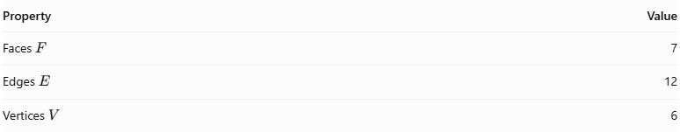
Property | Value
Faces $F$ | 7
Edges $E$ | 12
Vertices $V$ | 6
Its Euler characteristic is:
$$V-E+F=6-12+7=1$$
The value 1 is consistent with its non-orientable surface structure.

Non-Orientability
# Source: AI Source: Provided by: [Data Path: Persons Table -> ID Column: 1, Name_En Column: Motasem Essam] -> From: [ChatGPT] on [7/25/2026]
A defining property of a cuploid is non-orientability.
This means that its surface cannot be assigned a consistent global orientation. Unlike an ordinary orientable polyhedral surface, it does not have two globally distinguishable sides.
This is a topological property, not simply a consequence of its crossed appearance.

Relationship to Other Solids
# Source: AI Source: Provided by: [Data Path: Persons Table -> ID Column: 1, Name_En Column: Motasem Essam] -> From: [ChatGPT] on [7/25/2026]
The Crossed Triangular Cuploid belongs to the broader family of cuploids.
Other examples include:
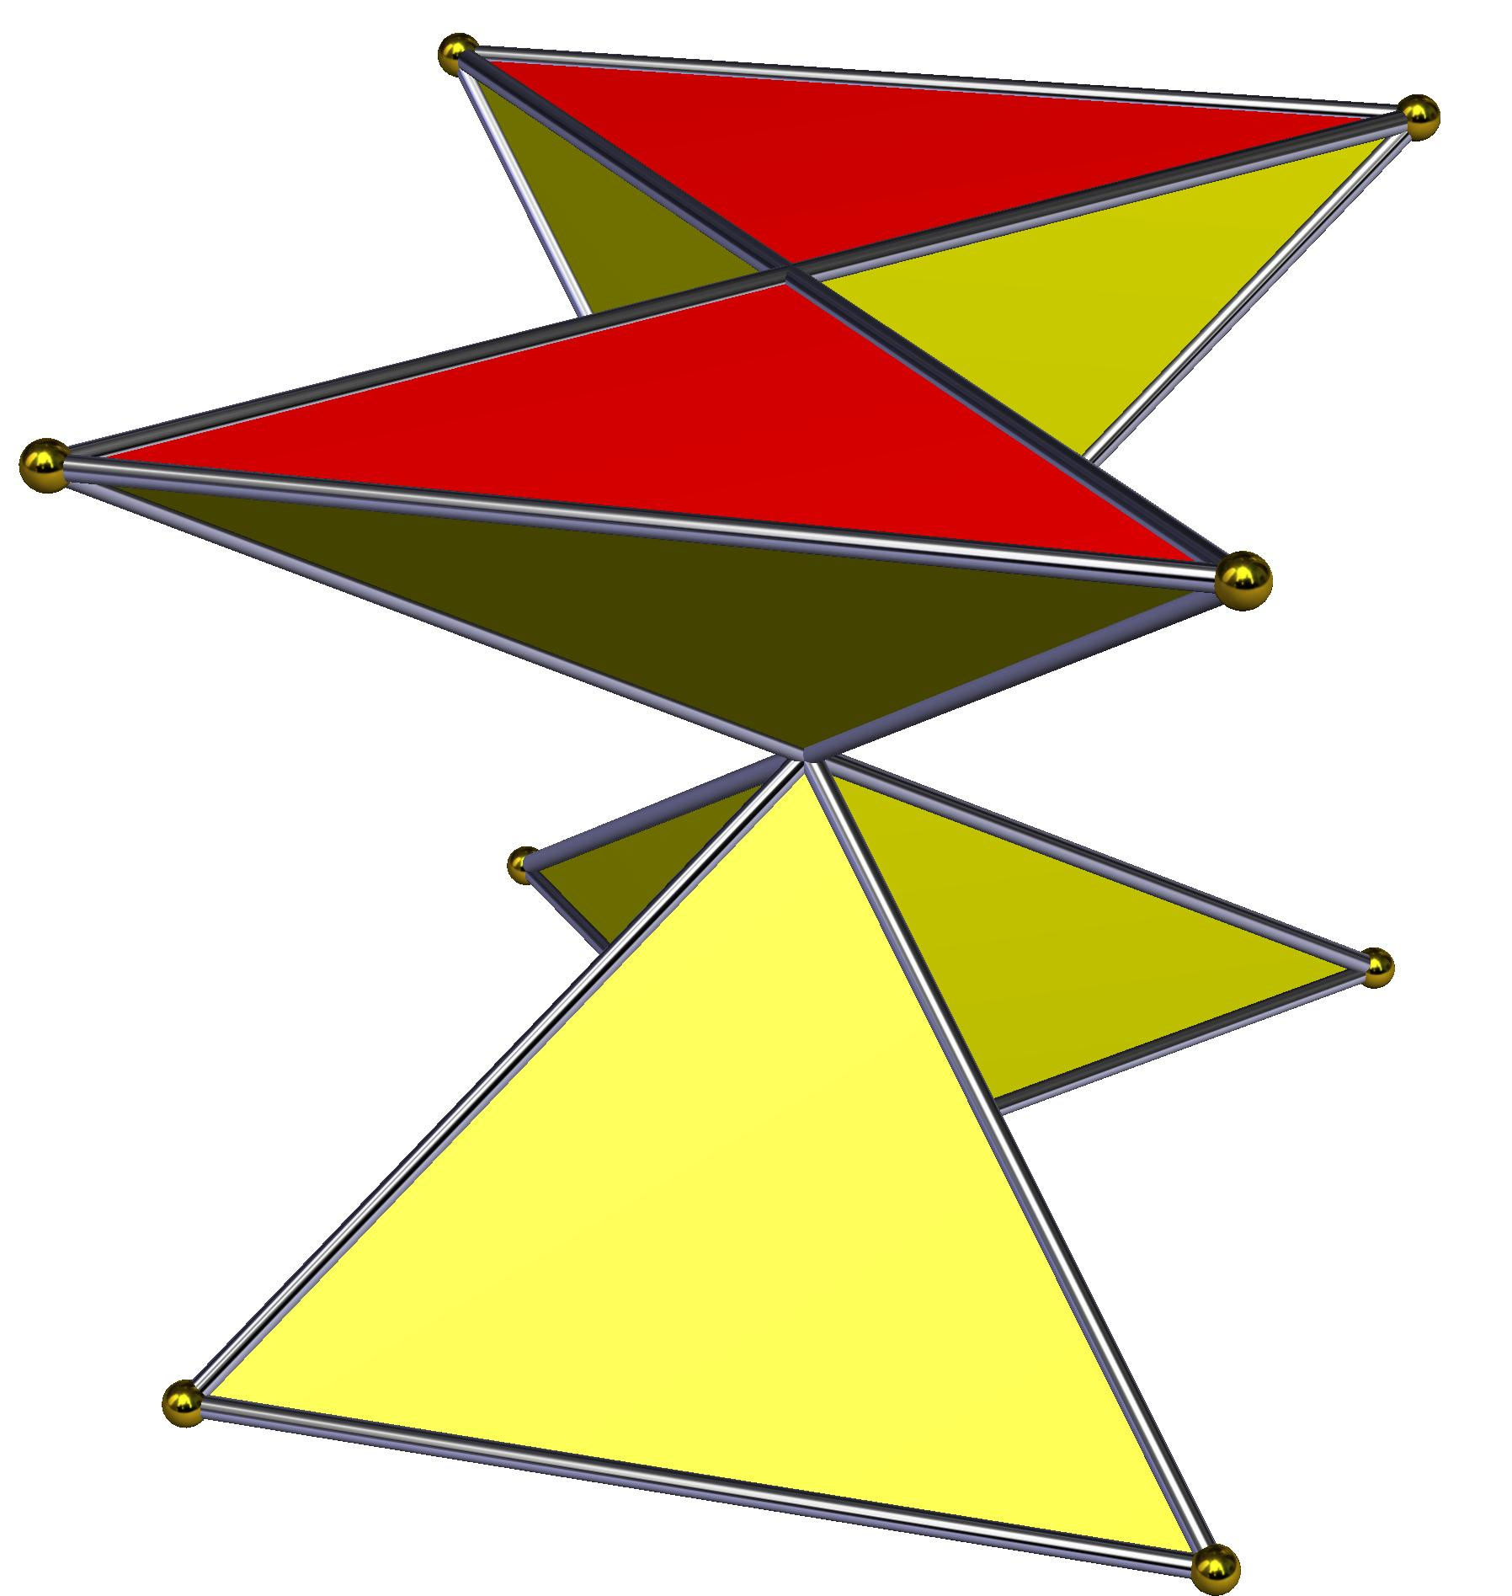
Crossed Triangular Cuploid
{3/2}
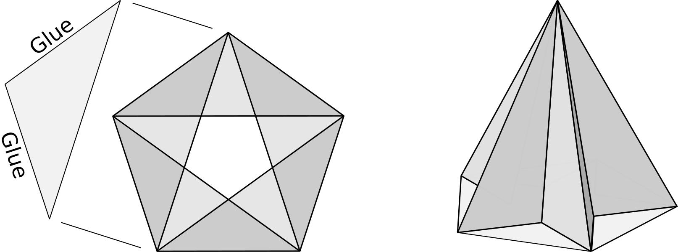
Pentagrammic Cuploid
{5/2}
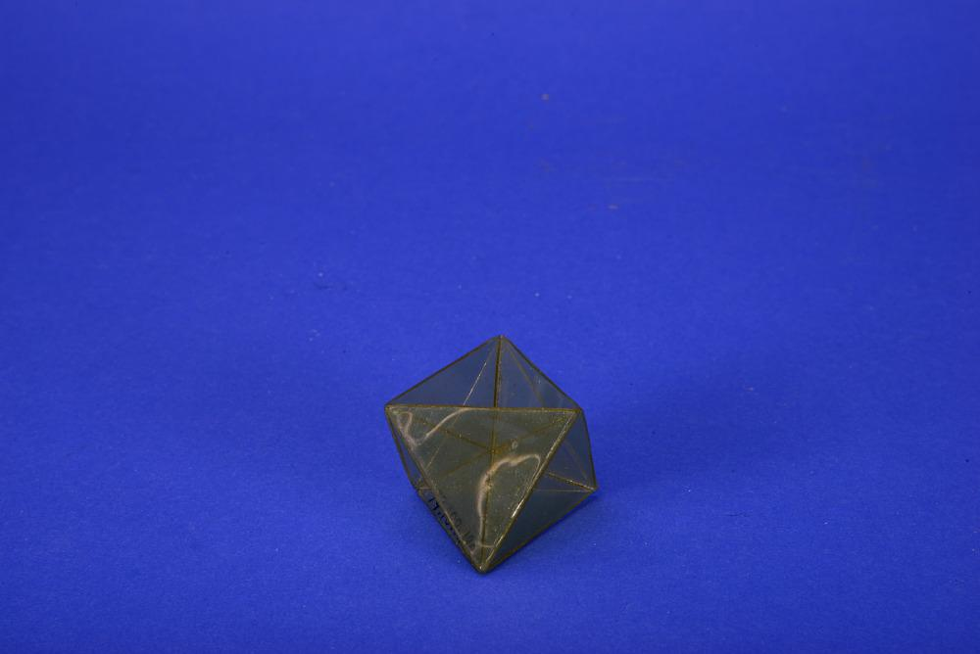
Heptagrammic Cuploid
{7/2}
Crossed Pentagonal Cuploid
{5/4}

Construction of a Crossed Triangular Cuploid

Geometric Instruments Used
# Source: AI Source: Provided by: [Data Path: Persons Table -> ID Column: 1, Name_En Column: Motasem Essam] -> From: [ChatGPT] on [7/25/2026]
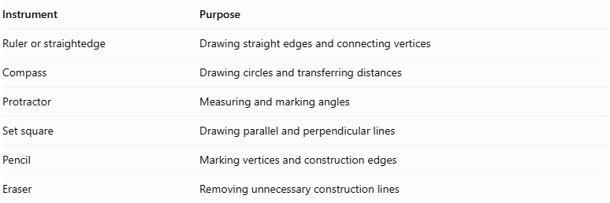
Instrument | Purpose
Ruler or straightedge | Drawing straight edges and connecting vertices
Compass | Drawing circles and transferring distances
Protractor | Measuring and marking angles
Set square | Drawing parallel and perpendicular lines
Pencil | Marking vertices and construction edges
Eraser | Removing unnecessary construction lines
Construction method: Instrument-based geometric construction using geometric instruments, angular measurements, and geometric relationships. It does not use coordinate-based construction.

Instrument-Based Construction Procedures

Preparing the Triangular Base
# Source: AI Source: Provided by: [Data Path: Persons Table -> ID Column: 1, Name_En Column: Motasem Essam] -> From: [ChatGPT] on [7/25/2026]
- Draw a circle using a compass.
- Mark three equally spaced points around its circumference.
- Connect the three points to construct an equilateral triangle.
- Mark the vertices consecutively as A, B, and C.
- Identify the intended crossed connection pattern.

Constructing the Crossed Triangular Arrangement
# Source: AI Source: Provided by: [Data Path: Persons Table -> ID Column: 1, Name_En Column: Motasem Essam] -> From: [ChatGPT] on [7/25/2026]
- Draw the required internal connecting edges according to the selected crossed configuration.
- Identify which vertices or edges must connect across the triangular arrangement.
- Mark the crossing locations where the construction requires intersecting edges.
- Distinguish actual vertices from visual intersections of edges.
- Complete the crossed triangular base arrangement.

Constructing the Second Base
# Source: AI Source: Provided by: [Data Path: Persons Table -> ID Column: 1, Name_En Column: Motasem Essam] -> From: [ChatGPT] on [7/25/2026]
- Draw a second triangular base.
- Make it congruent to the first base if the intended construction requires congruent bases.
- Position it parallel to the first base.
- Rotate or reverse its orientation according to the intended crossed arrangement.
- Mark the corresponding vertices.

Positioning the Bases
# Source: AI Source: Provided by: [Data Path: Persons Table -> ID Column: 1, Name_En Column: Motasem Essam] -> From: [ChatGPT] on [7/25/2026]
- Represent the two bases as parallel planes.
- Position the upper base above the lower base.
- Align the bases according to the selected crossed triangular configuration.
- Maintain threefold rotational symmetry if the arrangement is symmetrical.
- Check that the intended lateral connections can be formed without unintended gaps.

Constructing the Lateral Faces
# Source: AI Source: Provided by: [Data Path: Persons Table -> ID Column: 1, Name_En Column: Motasem Essam] -> From: [ChatGPT] on [7/25/2026]
- Connect the selected upper and lower base vertices.
- Construct the required triangular lateral faces.
- Construct any quadrilateral lateral faces specified by the chosen topology.
- Follow the crossed connection pattern.
- Verify that adjacent faces share matching edges.
- Check that the lateral structure closes correctly.

Completing the Three-Dimensional Representation
# Source: AI Source: Provided by: [Data Path: Persons Table -> ID Column: 1, Name_En Column: Motasem Essam] -> From: [ChatGPT] on [7/25/2026]
- Darken the visible edges.
- Use dashed lines for hidden edges where appropriate.
- Preserve the crossed triangular appearance.
- Check the threefold symmetry.
- Verify the overall face arrangement and closure.
Construction accuracy note: The procedure uses geometric instruments and geometric relationships. It is not coordinate-based construction. The exact construction steps for the lateral faces depend on the precise definition and topology of the Crossed Triangular Cuploid.

Key Points
# Source: AI Source: Provided by: [Data Path: Persons Table -> ID Column: 1, Name_En Column: Motasem Essam] -> From: [ChatGPT] on [7/25/2026]
- The Crossed Triangular Cuploid is represented by $\{3/2\}$.
- It belongs to the cuploid family.
- Its construction involves a degenerate lower base that is removed.
- Its faces connect through a crossed arrangement.
- It is non-orientable.
- It is closely associated with the Tetrahemihexahedron.
- In that realization, it has 7 faces, 12 edges, and 6 vertices.

Conclusion
# Source: AI Source: Provided by: [Data Path: Persons Table -> ID Column: 1, Name_En Column: Motasem Essam] -> From: [ChatGPT] on [7/25/2026]
The Crossed Triangular Cuploid is a specialized geometric construction that demonstrates how star-polygon arrangements and degenerate bases can produce unusual non-orientable polyhedral surfaces. Its relationship to the Tetrahemihexahedron makes it an interesting example in advanced solid geometry and polyhedral topology.

